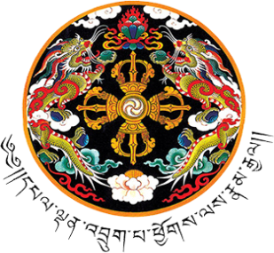
དཔལ་ལྡན་འབྲུག་གཞུང་།
ལྷན་རྒྱས་གཞུང་ཚོགས་ཡིག་ཚང་།
ROYAL GOVERNMENT OF BHUTAN
Cabinet Secretariat GyalyongTshogkhang Thimphu : Bhutan

CS/HRD-01/2023/1656 September 29, 2023

VACANCY RE- ANNOUNCEMENT
(In-Services Lateral Transfer)

The Cabinet Secretariat is pleased to re- announce the vacancy for the in- service following posts;

Sl  n o | Position | No.  of slot | Position Level | Qualification | Super structure | Agency
1 | Dy.Chief  /Sr./Media Officer | 1 | P5-P2 | Minimum Bachelors Degree | Administrative Services | PM Aides & Media Services , Office of the Prime Minister
2 | Dy.Chief  /Sr./Progra m Officer | 2 | P5-P2 | Minimum Bachelors Degree | Administrative Services | Public Service Delivery Division, Office of the Prime Minister

Interested In-service civil servants who meet the eligibility criteria may submit the application latest by October 13, 2023 through Zhiyog Recruitment System.
For further clarification, please contact HRS at 336667 during office hours.

Dy. Chief HRO

GyalyongTshogkhang, Thimphu P.O Box No. 1011 Tel. +975-2-336842 (Secretary), 321437 (PABX Tashichhodzong), 336667,
336065, 336780, 336678, 336727, 336844, 336067 (PABX Gyalyongkhang), Fax +975-2-321438 (Tashichhodzong),
336665 (GyalyongTshogkhang) Web: www.cabinet.gov.bt

